**PRE-LAB REPORT**

**Experiment No :** 08

**Name of The Experiment :** Observation of the effect Slew rate of op-amp

**Fig – 01 :** Circuit Diagram

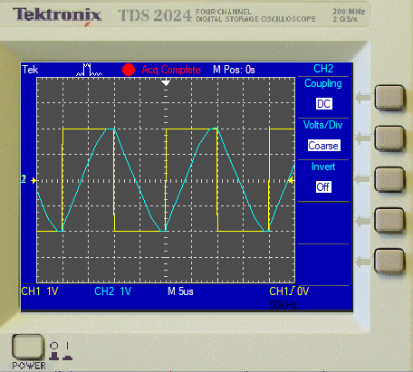

**Fig – 02 :** Input-Output

**Summary :** This experiment demonstrates how an op-amp's limited slew rate affects its ability to reproduce fast-changing signals. When a square wave input with high frequency or amplitude is applied, the output shows rounded edges due to the slew rate limit. This highlights the importance of slew rate in high-speed or large-amplitude signal applications.